More on the influence of gender equality on gender differences in economic preferences

# Abstract

This study replicates and extends the work of Falk and Hermle (2018), where gender differences in economic preferences (patience, altruism, willingness to take risks, negative and positive reciprocity, and trust) were hypothesized to be related to economic development and gender equality. During the replication, we found very similar results in terms of magnitude and statistical significance of the regression coefficients between aggregated gender differences in economic preferences with economic development and gender equality. However, we also identified several points that challenge the original analysis and require further research. Specifically, we examined the use of an ad hoc joint index for gender inequality and exclusively employed well-established indexes from gender studies in our analysis. A positive and statistically significant association between gender differences in economic preferences and economic development conditional on gender equality still holds in the analysis of these indexes. However, in contrast to the original article, the evidence of the relationship between gender differences and gender equality conditional on economic development is weak. We delved deeper investigating the role of the separate economic measures, concluding that economic development plays a role in predicting average gender differences in economic preferences, whereas gender equality seems to have a lesser or potentially negligible influence.

# 1. Introduction

Published findings on gender differences in human perceptions and behaviors, such as happiness [@SPSU], competition [@10.1257/jel.47.2.448; @https://doi.org/10.3982/ECTA6690; @NBERw11474; @KPS], and work preferences [@BEBLO201819], and their relation to gender inequality, are frequently used to influence decisions and policy-making, both in the public and private sectors. In turn, gender inequality topics are becoming a more integral part of the agenda for many institutions and organizations, and the stakeholders need to reveal, estimate, monitor, and prevent gender inequalities on an individual, group, and nationwide level.

The study of behavioral gender differences on a world scale is challenging. One challenge that hampers progress is the lack of large and homogeneous data sets across different social groups and countries. In an influential article published in the Quarterly Journal of Economics [@10.1093/qje/qjy013], a world scale data set on economic prefereces, the Global Preference Survey within the Gallup World Poll 2012, was analyzed. It focused on general questions about the distributions of economic preferences - defined as patience, altruism, willingness to take risks, negative and positive reciprocity, and trust - in different countries, relating them to several variables from the Gallup World Poll, such as age, gender, education level, and others. The subsequent article [@doi:10.1126/science.aas9899], that we abbreviated in the following text as FH, used the same dataset but focused explicitly on the gender differences highlighted in the previous study and reported evidence for the relationships of gender differences in economic preferences with economic development and gender equality. Their analysis showed a large, positive, and statistically significant association between gender differences in economic preferences and economic development, as well as a smaller but positive and statistically significant association between gender differences in economic preferences and gender equality. Following the approach described in FH and analyzing the same data set, we managed to replicate their work and found very similar results in terms of the slope coefficients of linear regressions and statistical significance, as it will be described below. However, we also identified several critical points to consider which we developed further in our extended analysis.

FH findings, although statistically significant and socially relevant, pose additional questions that the authors are only vaguely discussing and reporting. The study mainly focused on general hypothesis testing, applying dimentionality reduction technique to aggregate gender differences in separate preferences into one joint index, and a variety of standardizing and normalizing procedures to the measurables. However, from the perspective of a policy-making [@fe72ed72-1164-372d-8510-e97ae443a587] and followup studies, it is also important to investigate in greater details the magnitude and contribution of the effects of gender differences for the abovementioned economic preferences. The present study aims to fill this gap.

Another relevant issue we address is the robustness of empirical findings based on the various indexes for gender equality, as, in contrast to economic development where GDP p/с is widely acknowledged, their choice is rather broad. With this regard, one point of concern is the lack of justification for FH to introduce customized indexes with limited final interpretability. In our analysis, we provided a list of possible shortcomings for the use of this custom aggregated index and some of its components. We then restricted our analysis exclusively to the indexes widely used by academic, governmental and other institutions [@WEF_report, @GGGreport2015].

Finally, we delve deeper into the topic of gender differences by focusing on separate preference measures – in contrast to aggregated gender differences, to reveal the possible major contributors to such differences with respect to economic development and gender equality.

The article is structured as follows: Section 2 presents the summary of FH original article, while Section 3 contains our replication of FH main findings. The first part of Section 4 is dedicated to the issues related to measuring gender inequality and the build of a custom index for this purpose, while the second part is reporting the magnitude of the effects of gender differences on aggregated and separate preference measures, relevant for both research and policy-making. Finally, in the Discussion and Conclusions (Section 5), we evaluate the relevance of our results for further studies and practical use in various areas.

The code used to perform the analysis, the input, and the output data are publicly available (or referenced to be downloaded) at https://github.com/scerioli/Global-Preferences-Survey.

# 2. Summary of the Original Article

In this section, we summarize the analysis and main findings of the original article [@doi:10.1126/science.aas9899]. The authors used the Gallup World Poll 2012 Global Preference Survey to measure gender differences in economic preferences across 76 countries, representing nearly 90% of the world population, with a total of almost 80,000 people surveyed and each country having around 1,000 participants. The economic preferences are defined as time preference (also referred to as patience in the study), altruism, willingness to take risks, negative and positive reciprocity, and trust.

The people participating in the survey were asked to answer qualitative and quantitative questions and their score on each preference was assigned based on a weighted mean of the answers given (for more details, we refer to @FH_SM, section “Extended Materials and Methods”). Therefore, for each person in the data set, each of the six economic preferences was scored. Additional individual-level variables indicating age, sex, education level, subjective math skills (as a proxy for cognitive skills), and household income quintile were collected.

The authors proposed two competing hypotheses to be tested:

1. Social role hypothesis: “Following social role theory, one may hypothesize that gender differences in preferences attenuate in more developed, gender-egalitarian countries [...]. As a consequence, according to the social role hypothesis, higher economic development and gender equality (and the associated dissolution of traditional gender roles) should lead to a narrowing of gender differences in preferences."

2. Resource hypothesis: "In contrast, there is reason to expect that gender differences in preferences expand with economic development and gender equality [...]. In sum, greater availability of material and social resources to both women and men may facilitate the independent development and expression of gender-specific preferences, and hence may lead to an expansion of gender differences in more developed and gender-egalitarian countries."

The FH analysis focused on the relationship s of gender differences in economic preferences with economic development and gender equality. To aggregate gender differences among the six economic preferences, a principal component analysis (PCA) was performed on the gender coefficients. The first component of the PCA was then used as a summary index for gender differences in economic preferences. The logarithm of GDP per capita (Log GDP p/c) was used as a proxy for the economic development of the countries under study, while for gender equality FH used a customized gender equality index, which they called the Gender Equality Index. This index is built using the first component of a PCA applied to four different indexes for gender equality: the World Economic Forum Gender Global Gap Index (WEF GGGI), the United Nations Development Programme Gender Inequality Index (UNDP GII), the ratio of female to male labor force participation (F/M LFP), taken from the World Bank database, and the Time Since Women's Suffrage (TSWS), from the Inter-Parliamentary Union Website.

The study reported a positive, large, and statistically significant correlation between gender differences in economic preferences and Log GDP p/c (r = 0.67, p-value < 0.0001), and between gender differences in economic preferences and the custom Gender Equality Index proposed by the authors (r = 0.56, p-value < 0.0001), as reflected in the Research article summary and the graphic abstract of FH study. The authors also conducted a conditional analysis to isolate the impact of economic development and gender equality. This time they reported the regression coefficient being large and statistically significant (slope coefficient = 0.53, p-value < 0.0001) when gender differences were related to Log GDP p/c conditioned by Gender Equality Index, while moderately weak and statistically significant (slope coefficient = 0.32, p-value = 0.003) when relating to Gender Equality Index and controlling for Log GDP p/c.

The authors concluded that the evidence indicates that higher levels of economic development and gender equality favor the manifestation of gender differences in preferences across countries, “highlighting the critical role of availability of material and social resources, as well as gender-equal access to these resources, in facilitating the independent formation and expression of gender-specific preferences.” [@doi:10.1126/science.aas9899].

# 3. Replication of the Original Analysis

In this section, we describe the methodology used to replicate the analysis in FH and we compare our results to theirs. Additionally, we make use of the robust linear regression model on the same data to take into account the non-normality of the data set. We did not find any substantial differences from the results of FH study.

## 3.1 Data

To conduct the replication, we downloaded the Gallup World Poll 2012 Global Preferences Survey data set from the [briq - Institute on Behavior & Inequality](https://www.briq-institute.org/global-preferences/home). The full data set is under restricted access, and education level and household income quintile on the individual level are not available in the open-access version (for more information, see Supplementary Material "Data Collection, Cleaning, and Standardization"). In their Supplementary Material @FH_SM, FH provides a complementary analysis where all the independent variables (except for gender) are dropped, and the results are coherent with what was found in their main analysis. Therefore, we decided to continue the replication study without having access to education level and income quintile.

## 3.2 Methods and Results

Following the analysis conducted by FH, we built a multilinear regression model to assess the relationship between each of the six economic preferences, standardized at the global level to exhibit a mean of 0 and a standard deviation of 1, and the independent variables associated to the individuals across countries:

$preferenc{e_{i}}^{c} = {β_{1}}^{c} female_{i} + {β_{2}}^{c} age_{i} + {β_{3}}^{c} ag{e^{2}}_{i}+ {β_{4}}^{c} subj math skills_{i} + ϵ_{i}$

where the subscript *i* is the index of a survey participant and *c* is the index for a country. This results in six models – one for each economic preference – with four coefficients. The coefficient for the dummy variable $female$, ${β_{1}}^{c}$, is used as a measure for gender difference. The multilinear regression has been conducted independently for each country. Therefore, in total, there is one coefficient representing gender differences for each of the six economic preferences for 76 countries.

We performed a PCA on the six coefficients for gender differences in separate preference measures and used the first component to obtain a single measure for gender differences. FH referred to this summarized index as "average gender differences". We find this nomenclature potentially confusing, therefore we refer to it as either “aggregated index”, or as “summarized index”, rather than "average". The PCA technique has also been applied to the four gender equality indexes to get the joint index (Gender Equality Index) already described in Section 2 of this paper.

The competing hypotheses proposed by FH and described in Section 2 can be formally written using the following multilinear model:

$Gender Diff = β_{econdev} Econ Dev + β_{gender equality} Gender Equality$

Where the variable *Econ Dev* is always Log GDP p/c, while *Gender Equality* can be either the Gender Equality Index, or one of its sub-indexes (WEF GGGI, UNDP GII, F/M LFP, and TSWS).

Therefore, we would expect that:

1. If the social role hypothesis is correct, the model above will result in negative coefficients for economic development and gender equality.

2. If the resource hypothesis is correct, then we will have positive coefficients for economic development and gender equality.

Following these statements, the null hypothesis is that there is no correlation between gender differences in economic preferences and economic development, and between gender differences in economic preferences and gender equality. Any other scenario (for example, when one coefficient in the model is positive and the other is negative) is left out of the original hypotheses and would require the formulation of additional hypotheses and further studies.

Since the correlation between economic development and gender equality is a known effect [@10.2307/23644911; @GGGreport2015], we checked the correlation between their proxies, regressing Log GDP p/c on the Gender Equality Index built by FH. The correlation found is moderately strong (r = 0.54) and statistically significant (p-value < 0.0001), as one can see in the Supplementary Material, Figure 3. The multilinear regression takes into account this correlation, and the theorem from Frisch–Waugh–Lovell [@10.2307/1907330; @doi:10.1080/01621459.1963.10480682] guarantees that the coefficients found are the same as those found in the residual analysis, as performed in FH.

Noteworthy, a major part of FH analysis uses additional standardization procedures for dependent and independent variables of Equation 2, in addition to the standardization procedure performed for preference measures in Equation 1. We follow the same procedure in replication to compare our analysis with FH’s. However, during our extended analysis of gender equality indexes and separate preference measures (Section 4), we also calculated regression coefficients for the non-standardized summarized index and gender differences in each preference. Without standardization, the effects are expressed in measured gender differences in economic preferences. Standardization of the Log GDP p/c and gender equality indicators was still performed in all cases.

We summarize in Table 1 the comparison of our analysis to the one performed in FH study (from Figures 2 A-F of @doi:10.1126/science.aas9899). The results found are all in agreement with the original ones (although with some differences in p-values), except for the coefficient found for TSWS. The difference is not surprising, as TSWS was one of the most difficult indicators to replicate because of a lack of clear instructions in FH study (see also our Supplementary Material, "Data Collection, Cleaning, and Standardization"). Note also that the coefficients for economic development conditional on the four single indexes for gender equality are not provided in the original analysis.

## 3.3 Robust Linear Regression

Within the Global Preference Survey, economic preferences were measured with both qualitative and quantitative responses. For all the economic preferences, a qualitative question based on a Likert scale between 0 and 10 was used, while a quantitative measurement was performed for every preference excluding trust (please refer to @FH_SM for further details). This mixed approach of semi-continuous and ordered categorical variables has led us to the question of the appropriateness of the OLS method for the data analysis.

A diagnostic test on the data for each preference and each country, carried out using a Shapiro-Wilk test, indicated the presence of non-normality for all the measured economic preferences. In all cases, the distribution of the data has been detected to be non-normally distributed.

Based on this outcome, we ran the previous analysis using robust linear regression (RLR) instead of ordinary linear regression, to mitigate potential biases introduced by outliers. The results obtained with the robust linear regression did not differ significantly from the original and the replication analysis (see Table 1 below).

| **Coefficient** | **Regression on** | **Conditional on** | **FH**  **(OLS)** | **Replication (OLS)** | **Replication (RLR)** |
| --- | --- | --- | --- | --- | --- |
| $$β_{economic development}$$ | Log GDP p/c | Gender Equality Index | 0.5258*** | 0.50 (0.09)*** | 0.49 (0.10)*** |
| $$β_{economic development}$$ | Log GDP p/c | WEF GGGI | - | 0.62 (0.09)*** | 0.63 (0.09)*** |
| $$β_{economic development}$$ | Log GDP p/c | UNDP GII | - | 0.40 (0.20)* | 0.42 (0.20)* |
| $$β_{economic development}$$ | Log GDP p/c | F/M LFP | - | 0.66 (0.08)*** | 0.65 (0.09)*** |
| $$β_{economic development}$$ | Log GDP p/c | TSWS | - | 0.64 (0.09)*** | 0.63 (0.09)*** |
| $$β_{gender equality}$$ | Gender Equality Index | Log GDP p/c | 0.3192** | 0.36 (0.09)*** | 0.34 (0.10)** |
| $$β_{gender equality}$$ | WEF GGGI | Log GDP p/c | 0.2327** | 0.22 (0.09)* | 0.21 (0.09)* |
| $$β_{gender equality}$$ | UNDP GII | Log GDP p/c | 0.2911 | 0.30 (0.20) | 0.30 (0.20) |
| $$β_{gender equality}$$ | F/M LFP | Log GDP p/c | 0.2453* | 0.22 (0.08)** | 0.20 (0.09)* |
| $$β_{gender equality}$$ | TSWS | Log GDP p/c | 0.2988** | 0.19 (0.09)* | 0.19 (0.10)* |

Table 1: Comparison of the conditional analysis results from FH study (where OLS was used) and our replication using the OLS and the RLR. Reported are the coefficients of the linear regressions and the corresponding p-values. In parenthesis, we indicate the standard error of the coefficient. Note that the errors related to FH study are missing because they were not reported in the article. Significance levels: ≤ 0.001 (***), ≤ 0.01 (**), ≤ 0.05 (*).

# 4. Analysis of Gender Equality Indexes and Separate Preference Measures

This section brings attention to various unresolved concerns regarding the Gender Equality Index built by FH, where one of the main significant issues is the lack of interpretability associated with this index. We also delve deeper into the relationship between the separate preference measures and gender equality because it can help us better understand where the largest differences come from and therefore it may help shed light, or provoke new research on the specific associations found. We extended the analysis to state-of-the-art indexes such as WEF GGGI, UNDP GII, and UNDP Gender Development Index (GDI).

## 4.1 Gender Equality Indexes and Potential Issues

One concern is the way the Gender Equality Index proposed by FH was built and the reason why it was taken as a measure of gender equality. The justification for using this custom index rather than internationally recognized, studied, adopted, and already available indexes was omitted in FH study. To characterize the structure of the Gender Equality Index, we visualized its composition with the diagram shown in Figure 1. We will briefly summarize the main issues found below.

* The most critical point for the use of PCA is the interpretability of the index, which is a central question when it comes to building an index that can measure differences in society without losing its descriptive power and the ability to identify effective policies for closing the gender gap [@GGGreport2015].
* As seen in Figure 1, the components of the Gender Equality Index used in FH study contain repetitions. The two indexes WEF GGGI and UNDP GII share three sub-indexes, indicated here with different colors: *ratio of female to male labor force participation* (purple), the *share of seats in parliament* (green), and *enrollment into secondary education* (blue). As a third variable to construct the Gender Equality Index, FH used the *ratio of female to male labor force participation*, already included in the previous two indexes as a weighted sub-index. While the PCA technique in some cases permits the aggregation of variables even in the presence of large correlations among the inputs, in the present case, such a procedure may lead to an imbalance in favor of these specific repetitive indexes (especially female and male labor force participation) over other factors, which were already balanced in the design of WEF GGGI and UNDP GII indexes.
* The TSWS indicator, introduced by FH, is used as a proxy to track the long-lasting effects of the right to vote. It is based on the assumption that, during the time, development has always had a monotonic effect and its magnitude is proportional to the time since women’s suffrage was established. The data on the year of suffrage is available on a global scale but provides a minimal overview of gender disparities in politics, as discussed in @GIS1820. Indeed, even after the right to vote has been granted, many discriminating laws may still be present, and the alignment of laws together with the executive branch of the government and elimination of discrimination takes more time – despite gaining the right to vote, there may not be an improvement of gender equality in other areas (@Yang). For instance, the right to work can still be suppressed for several decades; as an example, in Western Germany married women could only work upon permission of their husbands until 1977 (@RecoPolicyGer, [page](https://link.springer.com/book/10.1007/978-3-531-91924-9) 92). The assumption that suffrage played a long-lasting effect on the balance of gender equality sounds reasonable but requires further investigation to be used as a robust estimator. Note also that in Figure 1 for some countries there is no reported data for this indicator, therefore FH took the missing points from the WEF Global Gender Gap Report of 2006.

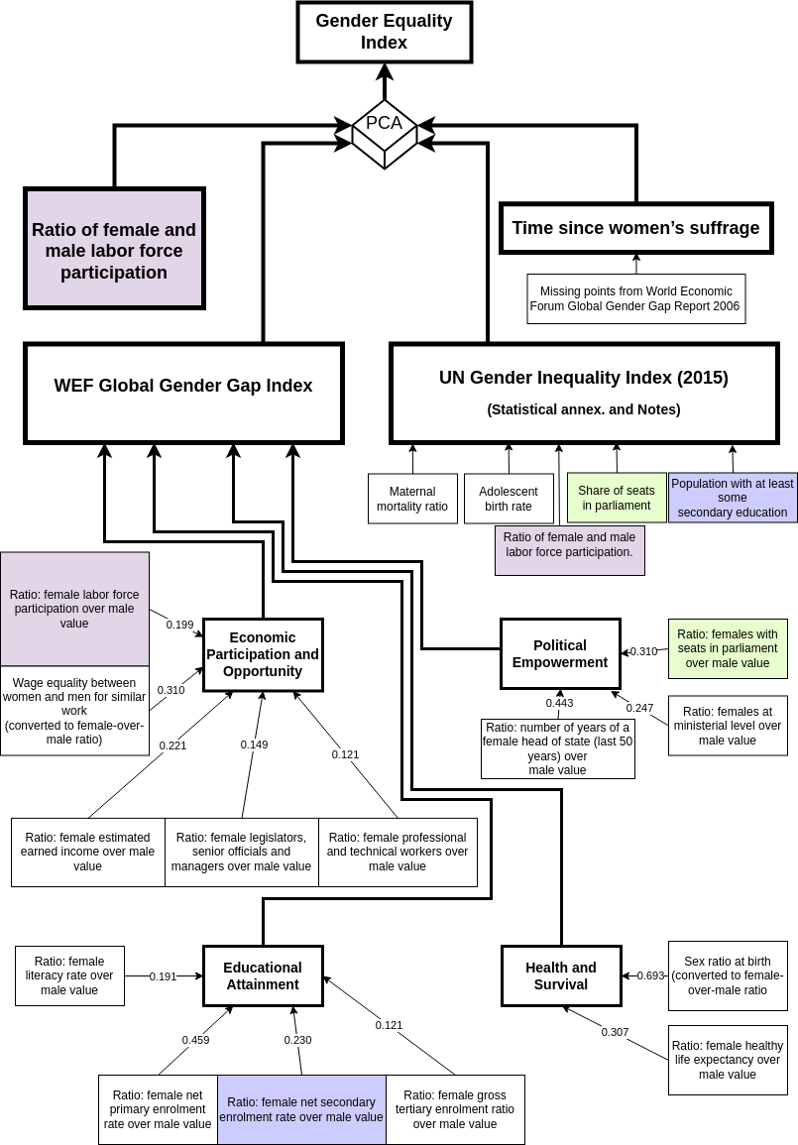

Figure 1: The custom Gender Equality Index decomposed into its sub-indexes, as built by FH. The repeated indexes and sub-indexes are highlighted with different colors. In the index "Time since Women's Suffrage", there are missing points that have been taken from another source, WEF Global Gender Gap Report 2006, following the approach used in FH study. Note that for each sub-index WEF GGGI calculates a weight to balance its impact on the overall index, while UNDP GII treats the sub-indexes without extra weighting. See also the technical notes of the @GGGreport2015 and of @UNDP2021.

For all the reasons above, we decided to avoid continuing with the use of this custom index, exclude the F/M LFP and the TSWS indicators from further analysis, and instead carry on only with WEF GGGI and UNDP GII.

Although these indexes are widely used by many researchers and policymakers, they are not exempt from critique. The UNDP GII has been criticized by several authors [@Klasen2017UNDP; @18350; @Permanyer], since it is highly correlated with economic development and includes reproductive health indicators that can penalize less-developed countries. Also, this index measures welfare loss associated with inequality based on a calculated gender equality measure which is not documented publicly. The power and limitations of WEF GGGI are discussed in two studies [@RePEc:spr:soinre:v:144:y:2019:i:3:d:10.1007_s11205-019-02080-5; @10.1080/13545701.2010.530607], though more research on this index is needed. As our investigation reveals (Figure 1), one point of concern is the inclusion of a subjective measure, based on an expert panel opinion, called "wage equality between men and women for similar work". This measure of economic participation and opportunity represents a substantial part (~30%) of the sub-index. The index is thought to be the least dependent on economic development since it measures the gap between male and female access to resources and opportunities [@GGGreport2015]. However, this dependence exists and is not negligible (see Supplementary Material, Figure 3).

We conducted extensive research in the literature to understand which options are available at this time to evaluate gender equality. In addition to the two above-mentioned indexes, we found that the Gender Development Index added from 2014 to the UNDP report is a good candidate for this kind of evaluation. This index is defined as the ratio of the Human Development Index for females to males, and it captures three dimensions in terms of health, knowledge, and living standards, separately for males and females. Life expectancy, the expected year of schooling and mean years of schooling, and GNI per capita are calculated within these dimensions. This index has been discussed in @Klasen2017UNDP, being praised for the clarity in interpretability and the focus on gender equality (rather than the sole female relative achievements). Therefore, we included this index in our extended analysis, along with WEF GGGI and UNDP GII.

## 4.2 Conditional Analysis of Gender Differences in Economic Preferences and Their Relationship to Economic Development and Gender Equality

Here, we explore the relationship between the summarized gender differences in economic preferences with economic development and gender equality, using the gender equality indexes referred to above (WEF GGGI, UNDP GII, and UNDP GDI). We run the same robust linear regression using the model in Equation 2 on these indexes and present the results in Figure 2. One can see that gender differences in economic preferences have a strong, positive, and statistically significant correlation with economic development when the conditional analysis is performed on the individual gender equality indexes. Conversely, the correlation between gender differences in economic preferences and gender equality, conditioned on economic development, is only statistically significant for WEF GGGI (r = 0.28, p-value = 0.0241), while for UNDP GII and GDI, the correlation is weak to null, with no statistical significance at 5% confidence level.

The standardization applied to the PCA of the coefficients of the gender differences ( ${β_{1}}^{c}$ in Equation 1) makes the interpretation of Figure 2 in terms of the magnitude of the effect less straightforward. The coefficient of gender differences shows how many standard deviations far apart are men and women for a given economic preference. When one additionally standardizes the ${β_{1}}^{c}$ coefficients for a given preference or PCA product for six preferences, the result shows how many standard deviations away is a certain country from the global average gender difference. In Table 2, we provide slope coefficients expressed in measured gender differences in economic preferences by omitting standardization and therefore accounting for the magnitude of change.

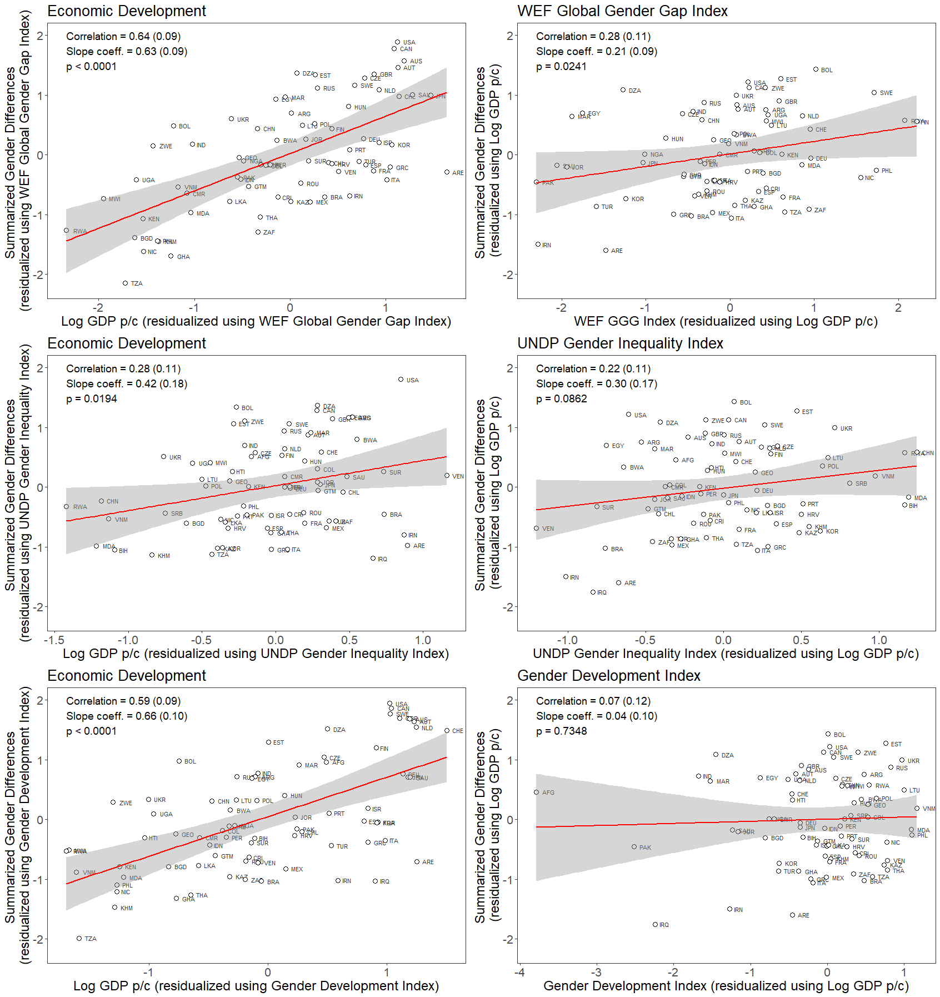

Figure 2: Correlation and slope coefficients between standardized gender differences in economic preferences and economic development, and between standardized gender differences in economic preferences and gender equality indexes, using the residuals plots. On the left, gender differences are regressed on economic development conditioned on gender equality for the different indexes (WEF GGGI, UNDP GGI, and GDI). On the right, the corresponding values of gender differences are regressed on gender equality indexes conditioned on economic development. We also report the corresponding p-values.

|  |  |  |  |
| --- | --- | --- | --- |
| **Coefficient** | **Regression on** | **Conditional on** | **Result** |
| $$β_{economic development}$$ | Log GDP p/c (Std) | WEF GGGI (Std) | 0.12 (0.02)*** |
| $$β_{economic development}$$ | Log GDP p/c (Std) | UNDP GII | 0.08 (0.03)* |
| $$β_{economic development}$$ | Log GDP p/c (Std) | UNDP GDI | 0.13 (0.02)*** |
| $$β_{gender equality}$$ | WEF GGGI (Std) | Log GDP p/c (Std) | 0.04 (0.02)* |
| $$β_{gender equality}$$ | UNDP GII | Log GDP p/c (Std) | 0.06 (0.03) |
| $$β_{gender equality}$$ | UNDP GDI | Log GDP p/c (Std) | 0.01 (0.02) |

Table 2: The magnitude of the change in summarized gender difference index, expressed in actual measured gender differences in economic preferences, in response to one standard deviation change in standardized Log GDP p/c or gender equality index. Slope coefficients of the regression between gender differences in economic preferences and economic development, and between gender differences in economic preferences and gender equality indexes, their standard errors in brackets and significance levels ≤ 0.001 (***), ≤ 0.01 (**), ≤ 0.05 (*) are reported. RLR method is used.

To investigate the role of economic development and gender equality on separate preferences, we used a multilinear regression model for each preference, similar to what we have done for the summarized gender differences:

$$Gender Dif{f^{p}}_{c} = {β^{p}}_{economic develop} Economic Develop + {β^{p}}_{gender equality} Gender Equality_{c} + ϵ_{c}$$

where index *c* indicates the country level, while the index *p* indicates economic preferences. $Gender Dif{f^{p}}_{c}$ indicates gender difference in the original six economic preferences and $Gender Equality_{c}$ indicates the three individual indexes (WEF GGGI, UNDP GII, and UNDP GDI) for gender equality.

As one can see in Table 3, the regression coefficient related to economic development (written as ${β^{p}}_{LogGDPp/c}$) is in most cases positive and statistically significant. On the other hand, when we look at the coefficients related to the gender equality index ( ${β^{p}}_{gender equality}$ of Table 4), we see that in 16 of the 18 regressor-regressee pairs, no statistically significant coefficients were observed. Only in two cases statistically significant coefficients were found: Between the pairs WEF GGG-Altruism and UNDP GII-Risk Taking.

It is important to highlight that FH also explored the separate preference measures by conducting a conditional analysis on Log GDP p/c and their custom Gender Equality Index. They found a statistically significant correlation between the Gender Equality Index and only three of the six preferences, while all the preferences were correlated with Log GDP p/c conditional on the Gender Equality Index (refer to Figures S5 and S6 in @FH_SM). To compare these results with ours, we present the correlation coefficients in the Supplementary Material (Tables 3 and 4). Note that the corresponding slope coefficients were not reported in FH article.

The analysis suggests that the association between gender differences in separate preference measures and economic development still holds (Table 3). Regression coefficients for separate economic measures show an increase in gender differences in the range between 0.03 and 0.07 standard deviations for one standard deviation change in Log GDP p/c, when conditioning on gender equality.

At the same time, the analysis demonstrates a lack of evidence of an association between gender differences in separate preference measures and gender equality indexes for the absolute majority of the preferences (Table 4). This absence of consistency seen in Figure 3 and Table 2, and overall significance in the results for gender dimension for the summarized and separate economic preferences, leads us to the conclusion that either there is an association but it is weak, or that such association does not exist at all. In the latter case, the set of hypotheses should not be limited to the two alternatives that were proposed as the main hypotheses in FH.

|  |  |  |  |
| --- | --- | --- | --- |
| **Preference** | $β_{LogGDPpc}$**(WEF GGGI)** | $β_{LogGDPpc}$**(UNDP GII)** | $β_{LogGDPpc}$**(UNDP GDI)** |
| Trust (+) | 0.06 (0.01)*** | 0.03 (0.02) | 0.07 (0.02)*** |
| Altruism (+) | 0.07 (0.01)*** | 0.08 (0.02)*** | 0.07 (0.01)*** |
| Pos. Recip. (+) | 0.03 (0.01)* | 0.03 (0.02) | 0.02 (0.01) |
| Neg. Recip. (-) | 0.04 (0.01)** | 0.01 (0.02) | 0.05 (0.01)*** |
| Risk Taking (-) | 0.04 (0.01)** | 0.00 (0.02) | 0.05 (0.01)** |
| Patience (-) | 0.04 (0.01)** | 0.02 (0.02) | 0.04 (0.01)** |

Table 3: The magnitude of the change in gender differences for single preferences per one standard deviation change in standardized Log GDP p/c. The slope coefficients for economic development from the eighteen multilinear regression models for separate economic preferences and three distinct choices of gender equality indexes (WEF GGGI, UNDP GII, UNDP GDI). As in the original article, the symbols (+)/(-) indicate the general direction of the difference. (+) indicates that women exhibited higher levels of the respective preference compared to the global average (-) indicates that men on average exhibited higher levels of the respective preference. The regression coefficients, their standard errors in brackets, and significance levels ≤ 0.001 (***), ≤ 0.01 (**), ≤ 0.05 (*) are reported. RLR method is used.

|  |  |  |  |
| --- | --- | --- | --- |
| Preference | $β_{Gender Eq}$ (WEF GGGI) | $β_{Gender Eq}$ (UNDP GII) | $β_{Gender Eq}$ (UNDP GDI) |
| Trust (+) | 0.01 (0.01) | 0.04 (0.02) | 0.01 (0.01) |
| Altruism (+) | 0.03 (0.01)** | -0.01 (0.02) | 0.01 (0.01) |
| Pos. Recip. (+) | 0.00 (0.01) | 0.00 (0.02) | 0.02 (0.01) |
| Neg. Recip. (-) | 0.01 (0.01) | 0.04 (0.02) | -0.01 (0.01) |
| Risk Taking (-) | 0.01 (0.01) | 0.05 (0.02)* | -0.01 (0.01) |
| Patience (-) | 0.02 (0.01) | 0.03 (0.02) | 0.01 (0.01) |

Table 4: The magnitude of the change in gender differences for single preferences per one standard deviation change in standardized gender equality. The slope coefficients for gender equality from the same eighteen multilinear regression models for separate economic preferences and three distinct choices of gender equality indexes. (WEF GGGI, UNDP GII, UNDP GDI). As in FH, the symbols (+)/(-) indicate the general direction of the difference. (+) indicates that women exhibited higher levels of the respective preference compared to the global average (-) indicates that men on average exhibited higher levels of the respective preference. The regression coefficients, their standard errors in brackets, and significance levels ≤ 0.001 (***), ≤ 0.01 (**), ≤ 0.05 (*) are reported. RLR method is used.

# 5. Discussion and Conclusions

In the present article, we replicated and extended the results of the work by @doi:10.1126/science.aas9899 which relates gender differences in economic preferences to economic development and gender equality.

As a first milestone, we performed a nearly exact replication, obtaining the data from the Gallup World Poll 2012 Global Preference Survey, using the same methodology as in FH. Unfortunately, the data set is publicly available only in a pre-processed form and is partially restricted. Nevertheless, we managed to replicate the analysis and the results were similar to those of the original article. In addition, we ran the same analysis using robust linear regression instead of ordinary linear regression, as the data revealed signs of non-normality and outliers, but no significant changes in the results were observed.

We then investigated the indexes used to estimate gender equality and their relationship with economic development. We analyzed the Gender Equality Index built by FH and its components. Some methodological issues were identified, and the usage of this custom index over a more established, balanced index lacks justification and remains to be questioned. Therefore, we conducted a further analysis based on separate, widely accepted indexes of gender equality used in the original article (WEF Global Gender Gap Index and UNDP Gender Inequality Index), plus an additional index – the UNDP Gender Development Index.

We examined gender differences in economic preferences and their relationship with economic development and gender equality using the above-mentioned indexes. Performing a conditional analysis, we found a positive, strong, and statistically significant correlation between the summarized gender differences in economic preferences and economic development, controlling for WEF GGGI and UNDP GDI, while controlling for UNDP GII yielded a somewhat milder correlation. On the other hand, when controlling for economic development, no correlation between UNDP GII or GDI and the summarized gender differences in economic preferences was found. Only the correlation between summarized gender differences in economic preferences and WEF GGGI was weak, but statistically significant. Therefore, the dependency of gender differences in economic preferences on gender equality can not be consistently supported when only established, commonly recognized indexes are used. This lack of consistency in the results leads us to the conclusion that either there is a weak correlation between gender differences in economic preferences and gender equality, or that the correlation does not exist at all. In the latter case, the set of hypotheses should not be limited to the two alternatives that were proposed as the main hypotheses in FH.

We additionally analyzed how gender differences in separate preference measures are related to economic development and gender equality. Interestingly, we observed contrasting patterns in the correlation coefficients between gender differences in each separate economic preference and both Log GDP p/c and gender equality, for WEF GGGI and UNDP indexes. Specifically, we found positive and statistically significant regression coefficients of small magnitude when examining the relationship between gender differences in separate preference measures and Log GDP p/c, when controlling for WEF GGGI and UNDP GDI. When controlling for UNDP GII, only one economic preference (altruism) shows a statistically significant regression coefficient of similar magnitude, while coefficients for the other preferences are not statistically significant. Meanwhile, among the six economic preferences studied in relationship with gender equality indexes, the only statistically significant regression coefficients were for altruism (which exhibited an association with WEF GGGI) and risk-taking (with an association with UNDP GII).

These findings align with our results obtained from the summarized gender differences. Yet, the dependencies of gender differences in economic preferences on economic development and gender equality became more nuanced once analyzed for separate economic measures, with a more differentiated picture emerging. This differentiation becomes particularly important in the realms of decision-making and policy formulation.

Meanwhile, the impact of economic development on the manifestation of gender differences in preferences should also be further investigated. It might be worth researching the origins of these gender differences, considering hypotheses encompassing economic development and other potential country-level variables not considered in FH that could explain the disparities observed. For instance, one may speculate that at the higher level of economic development, the market expands and diversifies its offerings to cater to a wider range of consumers, exploiting status quo gender stereotypes as a starting point for the promotion of goods. In this case, a potential accentuation of gender differences by reinforcing gender stereotypical behaviors may occur.

# References

@article{10.1093/qje/qjy013,

author = {Falk, Armin and Becker, Anke and Dohmen, Thomas and Enke, Benjamin and Huffman, David and Sunde, Uwe},

title = "{Global Evidence on Economic Preferences*}",

doi = {10.1093/qje/qjy013},

@article{doi:10.1126/science.aas9899,

author = {Armin Falk and Johannes Hermle },

title = {Relationship of gender differences in preferences to economic development and gender equality},

doi = {10.1126/science.aas9899},

@misc{ FH_SM,

author = {Falk, A. and Hermle, J.},

title = {Supplementary Materials of {R}elationship of gender differences in preferences to economic development and gender equality},

doi = {http://science.sciencemag.org/content/suppl/2018/10/17/362.6412.eaas9899.DC1}}

@article{10.2307/1907330,

URL = {http://www.jstor.org/stable/1907330},

author = {Ragnar Frisch and Frederick V. Waugh},

title = {Partial Time Regressions as Compared with Individual Trends},

@article{doi:10.1080/01621459.1963.10480682,

author = { Michael C. Lovell },

title = {Seasonal Adjustment of Economic Time Series and Multiple Regression Analysis},

doi = {10.1080/01621459.1963.10480682}

@article{SPSU,

author = {Schneider, Udo and Pfarr, Christian and Schneider, Brit and Ulrich, Volker},

title = {I feel good! Gender differences and reporting heterogeneity in self-assessed health},

doi = {10.1007/s10198-011-0301-7}

@article{https://doi.org/10.3982/ECTA6690,

author = {Gneezy, Uri and Leonard, Kenneth L. and List, John A.},

title = {Gender Differences in Competition: Evidence From a Matrilineal and a Patriarchal Society},

doi = {https://doi.org/10.3982/ECTA6690},

@article{10.1257/jel.47.2.448,

Author = {Croson, Rachel and Gneezy, Uri},

Title = {Gender Differences in Preferences},

Journal = {Journal of Economic Literature},

DOI = {10.1257/jel.47.2.448},

@article{BEBLO201819,

title = {On the nature of nurture. {The} malleability of gender differences in work preferences},

doi = {https://doi.org/10.1016/j.jebo.2018.05.002},

author = {Miriam Beblo and Luise Görges},

@techreport{Klasen2017UNDP,

author = {Stephan Klasen},

title = {UNDP's gender-related measures: Current problems and proposals for fixing them},

url = {http://hdl.handle.net/10419/157265},

@article{KPS,

author = {Klonner, Stefan and Pal, Sumantra and Schwieren, Christiane},

title = {Equality of the Sexes and Gender Differences in Competitiveness: Experimental Evidence from a Traditional Society with Gender-Balanced Norms},

doi = {10.2139/ssrn.3940199}

@inbook{18350,

title = {Gender Inequality in Human Development: Theories and Measurement},

booktitle = {Background Papers: Human Development Report 1995},

author = {Amartya Sen and Anand, Sudhir}

@article{Permanyer,

author = {Permanyer, Iñaki},

title = {Are {UNDP} Indices Appropriate to Capture Gender Inequalities in {E}urope?},

doi = {10.1007/s11205-011-9975-6}

@article{ Yang,

author = {Mimi Yang},

title = {An intimate dialog between race and gender at {W}omen’s {S}uffrage {C}entennial},

doi = {https://doi.org/10.1057/s41599-020-00554-3}}

@article{WEF_report,

author = {{World Economic Forum}},

publisher = {World Economic Forum},

title = {{G}lobal {G}ender {G}ap report 2006},

URL = {http://www3.weforum.org/docs/WEF_GenderGap_Report_2006.pdf},

@misc{ GGGreport2015,

author = {{World Economic Forum}},

title = {{G}lobal {G}ender {G}ap Report 2015},

URL=https://reports.weforum.org/global-gender-gap-report-2015/the-global-gender-gap-index-2015/

@article{RePEc:spr:soinre:v:144:y:2019:i:3:d:10.1007_s11205-019-02080-5,

author={Alan Piper},

title={{An Investigation into the Reported Closing of the Nicaraguan Gender Gap}},

journal={Social Indicators Research: An International and Interdisciplinary Journal for Quality-of-Life Measurement},

doi={10.1007/s11205-019-02080-},

url={https://ideas.repec.org/a/spr/soinre/v144y2019i3d10.1007_s11205-019-02080-5.html}

@article{10.1080/13545701.2010.530607,

author = { Angela Barns and Alison Preston },

title = {Is {A}ustralia Really a World Leader in Closing the Gender Gap?},

doi = {10.1080/13545701.2010.530607},

@article{10.2307/23644911,

ISSN = {00220515},

URL = {http://www.jstor.org/stable/23644911},

author = {Esther Duflo},

title = {Women Empowerment and Economic Development},

@misc{UNDP2021,

author = {{United Nation Development Programme}},

title = {{H}uman {D}evelopment {R}eport, technical notes},

URL =https://hdr.undp.org/sites/default/files/2021-22_HDR/hdr2021-22_technical_notes.pdf}

@book{GIS1820,

author = {Sarah Carmichael and Selin Dili and Auke Rijpma},

title = {Gender inequality since 1820},

doi = {https://doi.org/https://doi.org/10.1787/9789264214262-16-en}

@techreport{NBERw11474,

title = "Do Women Shy Away From Competition? Do Men Compete Too Much?",

author = "Niederle, Muriel and Vesterlund, Lise",

doi = {10.3386/w11474},

@book{RecoPolicyGer,

author = {Cornelius Grebe},

title = Reconciliation Policy in Germany 1998-2008

doi = {https://doi.org/10.1007/978-3-531-91924-9}